Tools We Use In Farming
‘

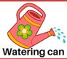

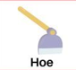

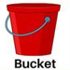

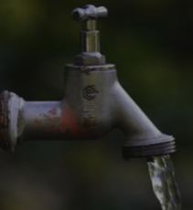
Water

